Intelligent Document Analysis Admin Panel
The admin panel allows to manage dynamic lists used in the Template Builder.

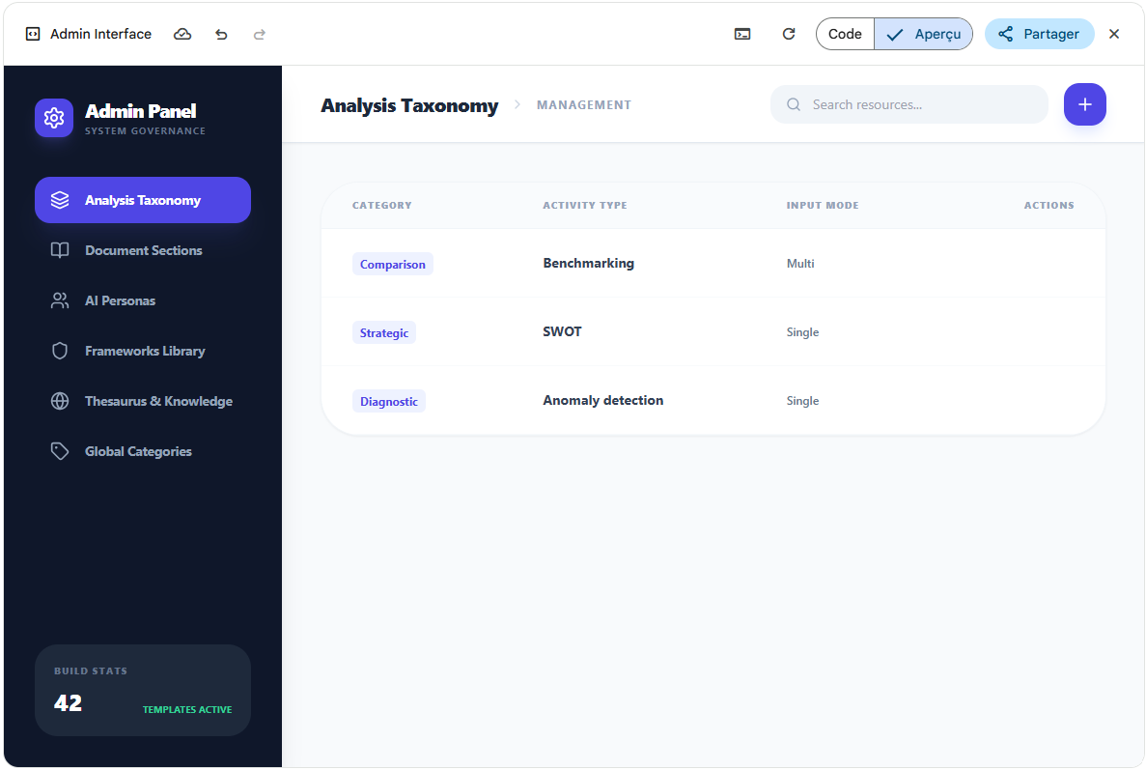
Figure 1: Admin Panel - The Taxonomy Screen
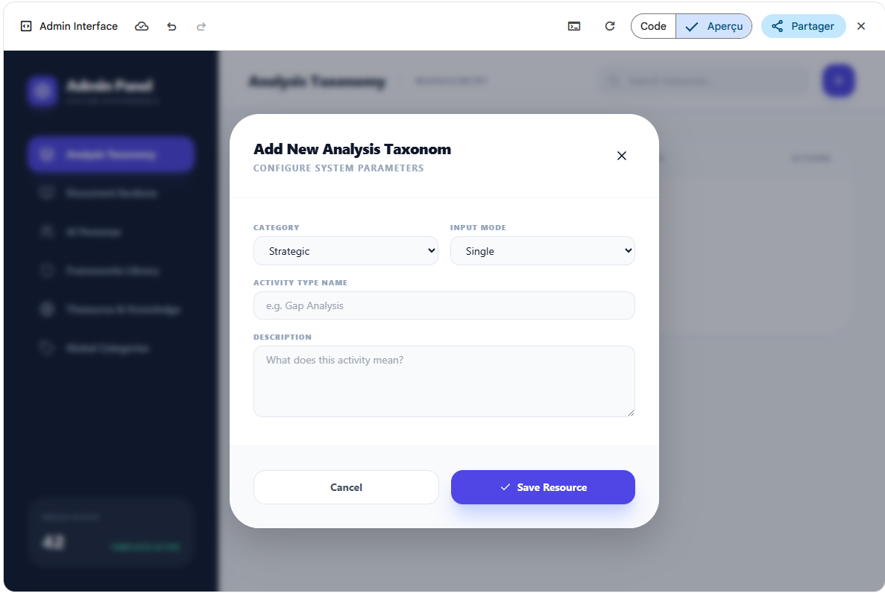
Figure 2: Adding a new Taxonomy
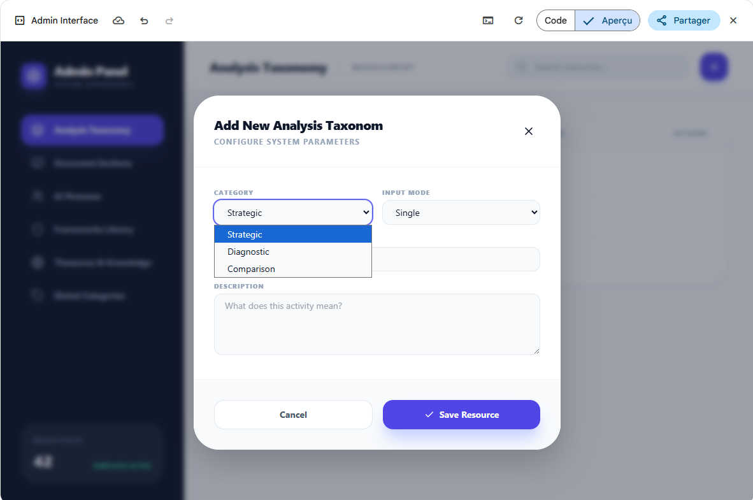
Figure 3: Drop down - List of categories of taxonomies
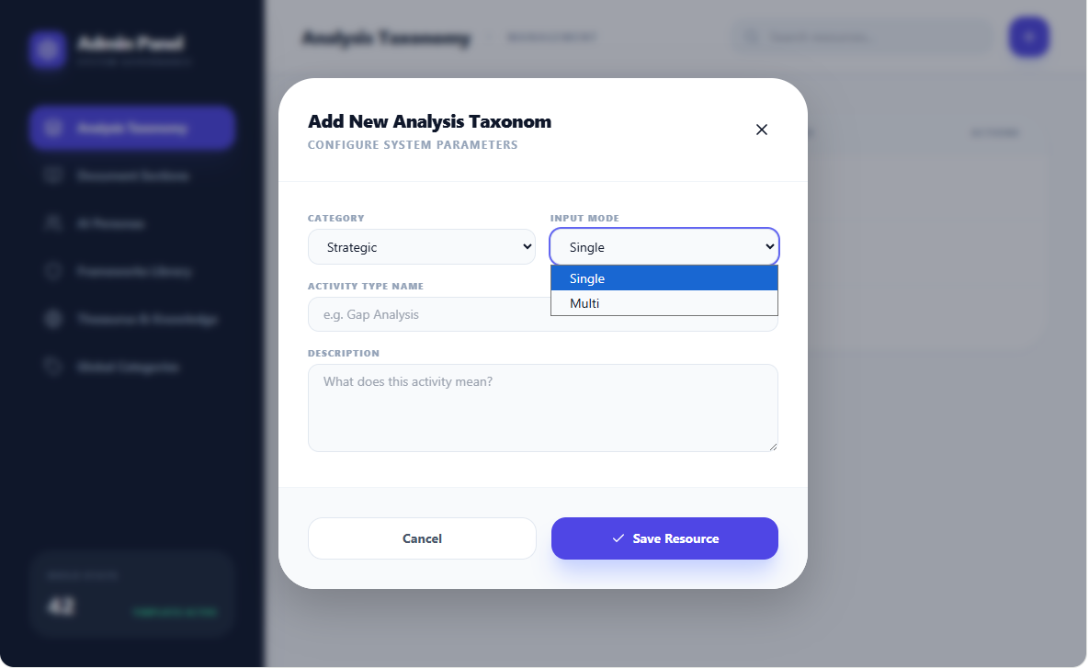
Figure 4: drop Down - List of Input Modes for Taxonomies
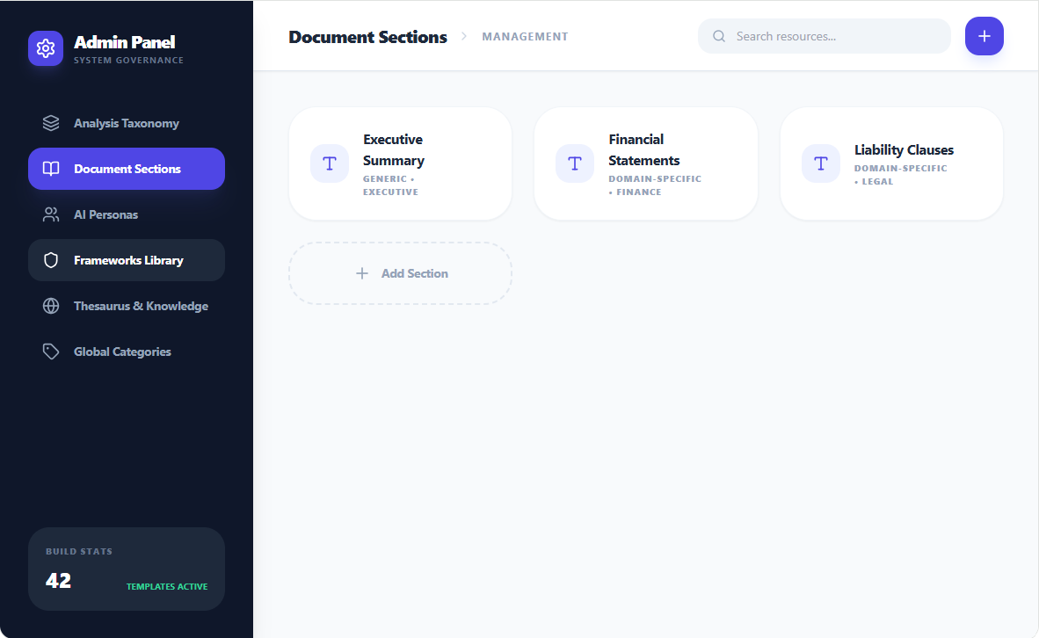
Figure 5: Admin Panel - Document Sections
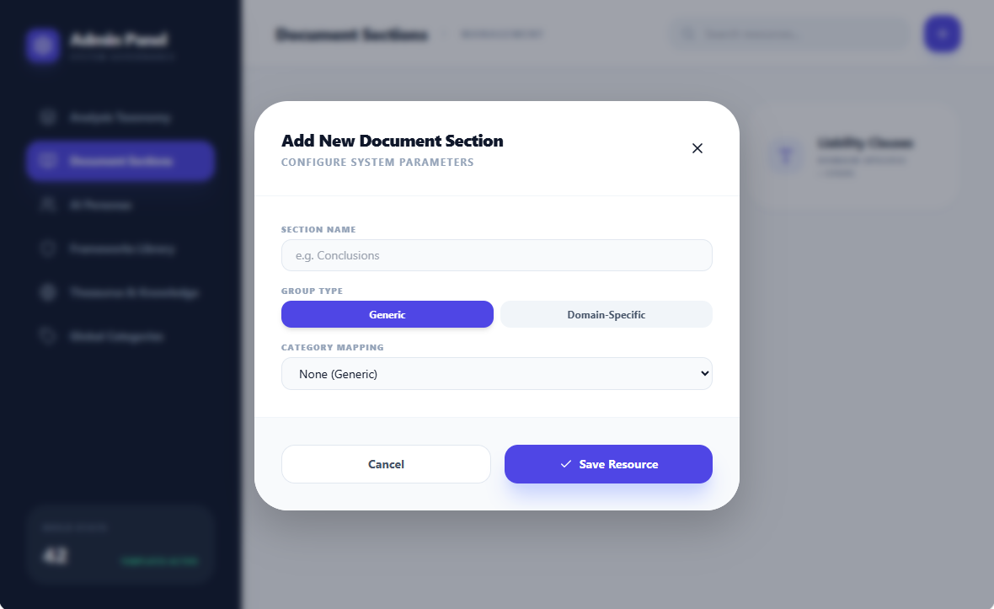
Figure 6: Adding a document section
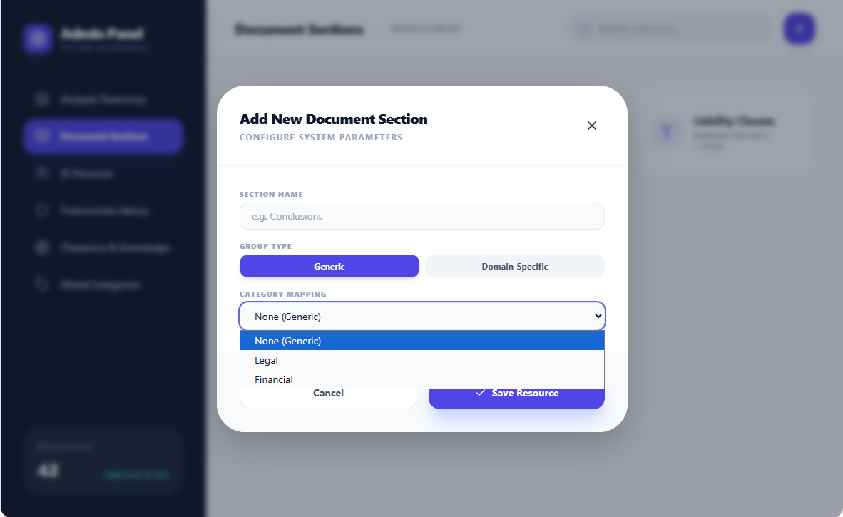
Figure 7: Document Sections - Drop Down for Document Sections Categories
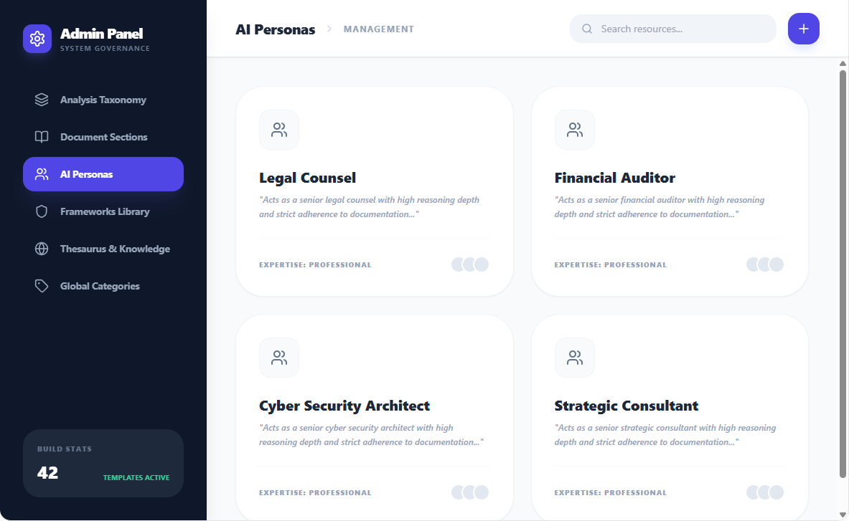
Figure 8: Admin Panel - AI Personas
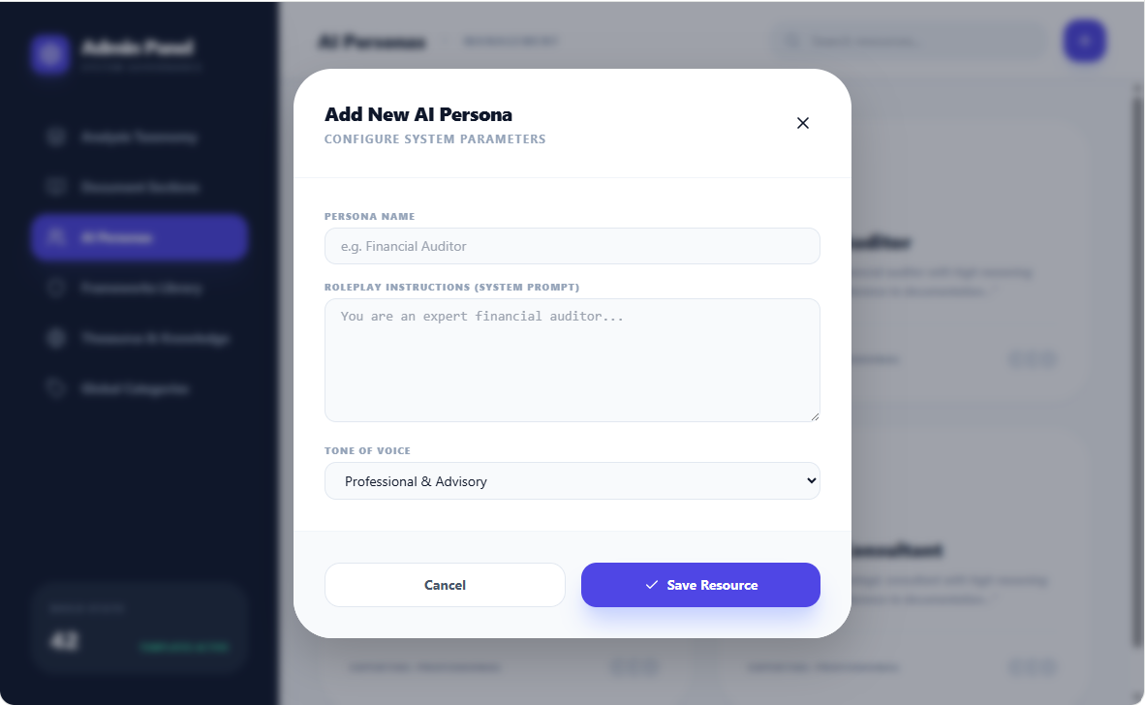
Figure 9: AI Personas - Adding an AI persona
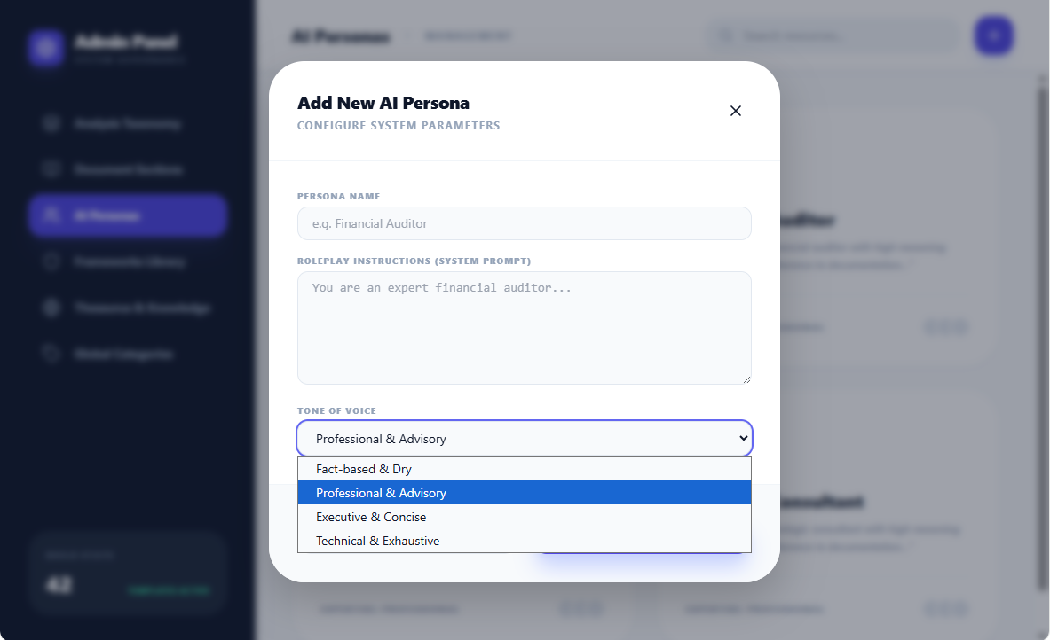
Figure 10: AI Personas - Tone of Voice
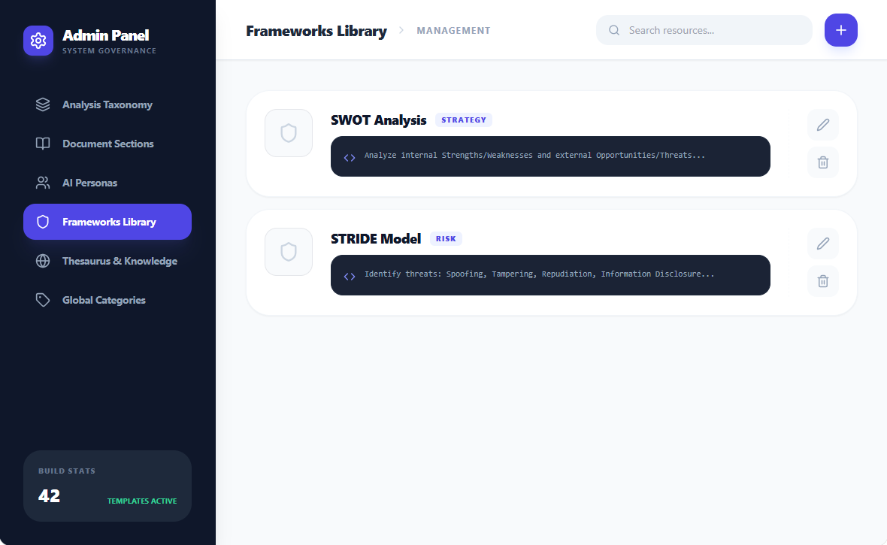
Figure 11: Admin Panel – Frameworks
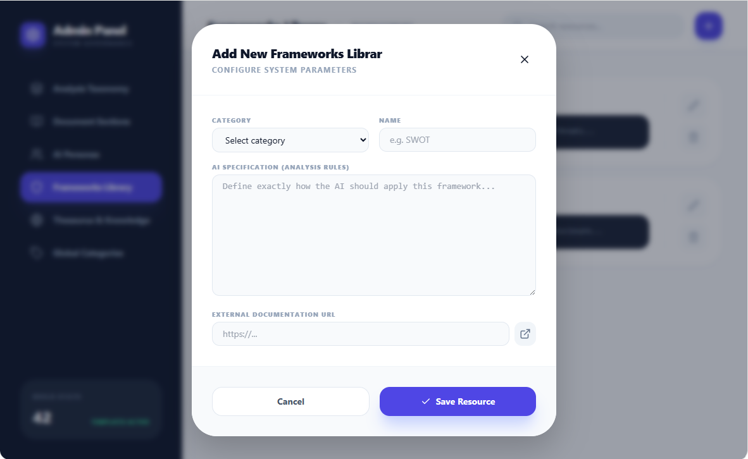
Figure 12: Frameworks - Adding a framework
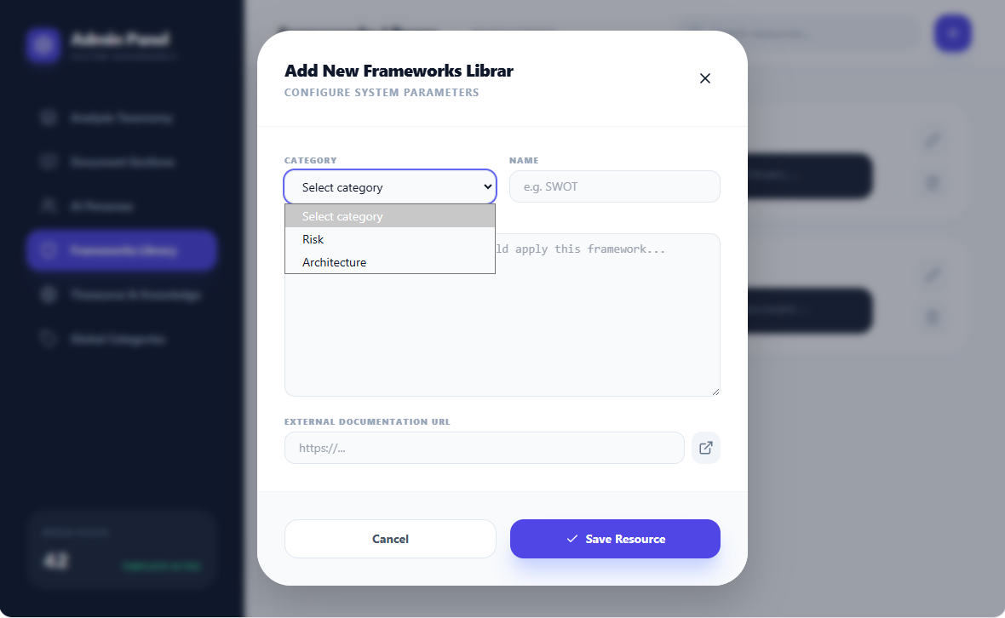
Figure 13: Frameworks - Drop Down - Categories of Frameworks
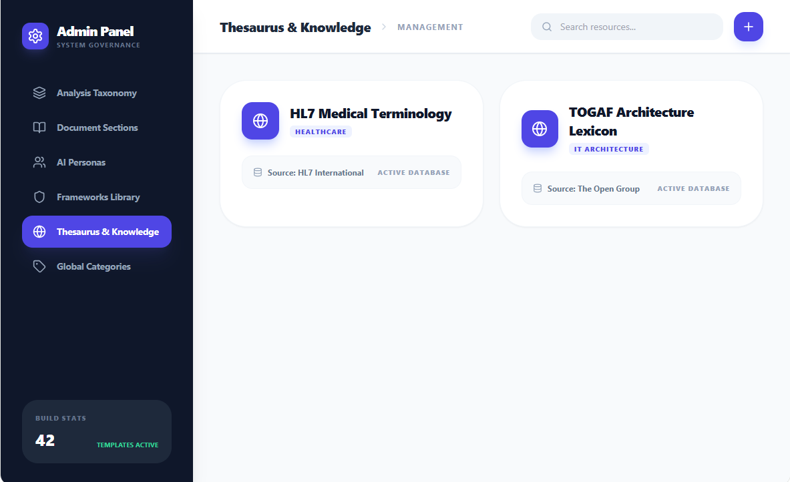
Figure 14: Admin Panel - Thesaurus & Knowledge
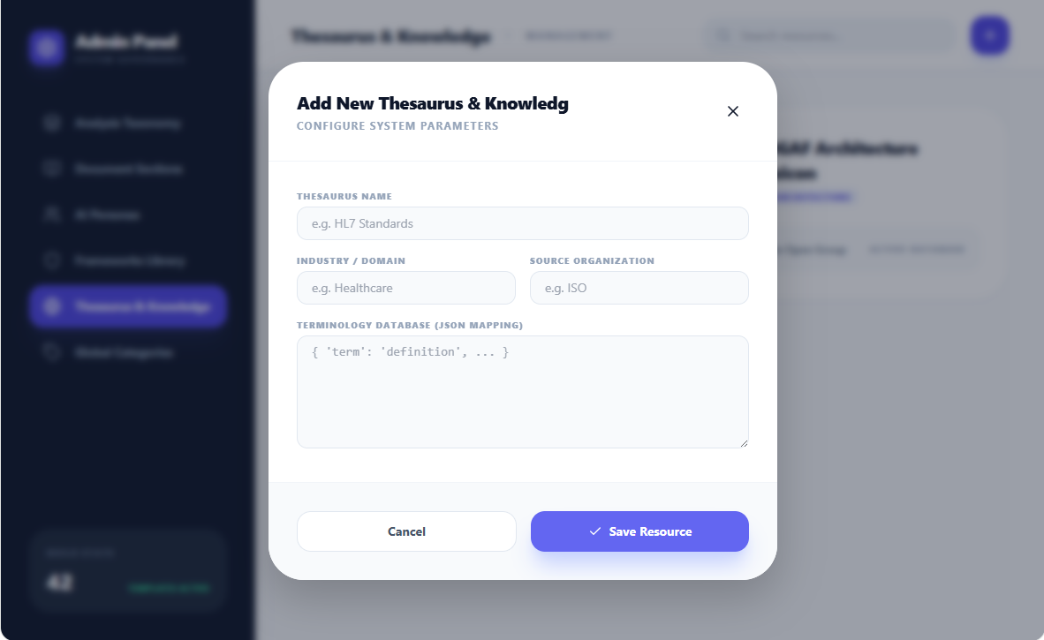
Figure 15: Thesaurus & Knowledge - Adding a Thesaurus
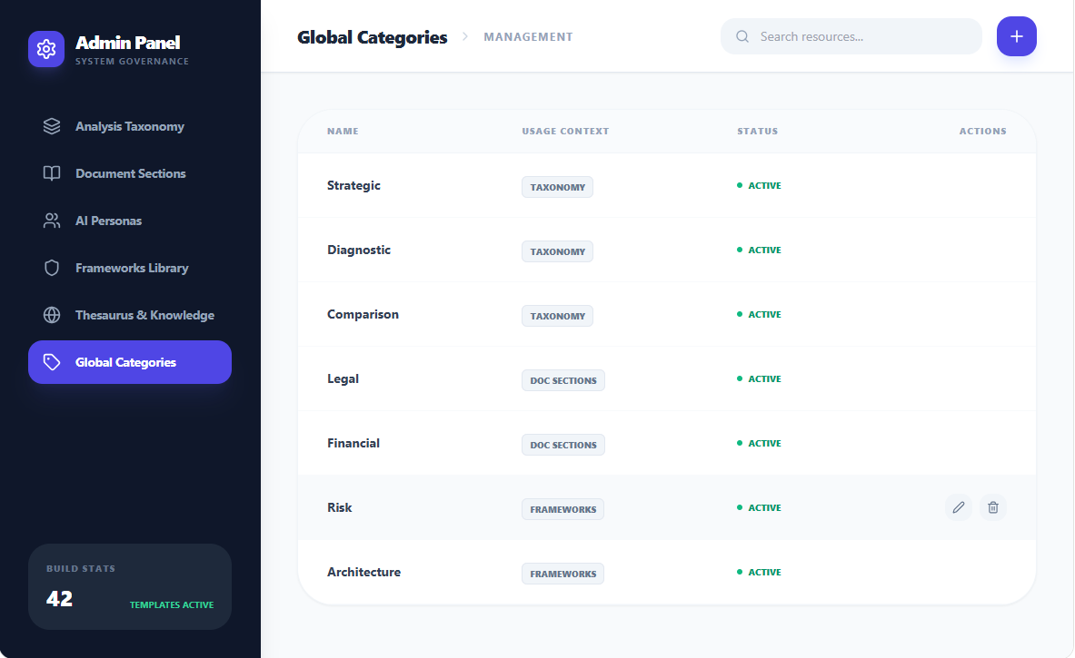
Figure 16: Admin Panel - Managing categories for other screens of the Admin Panel
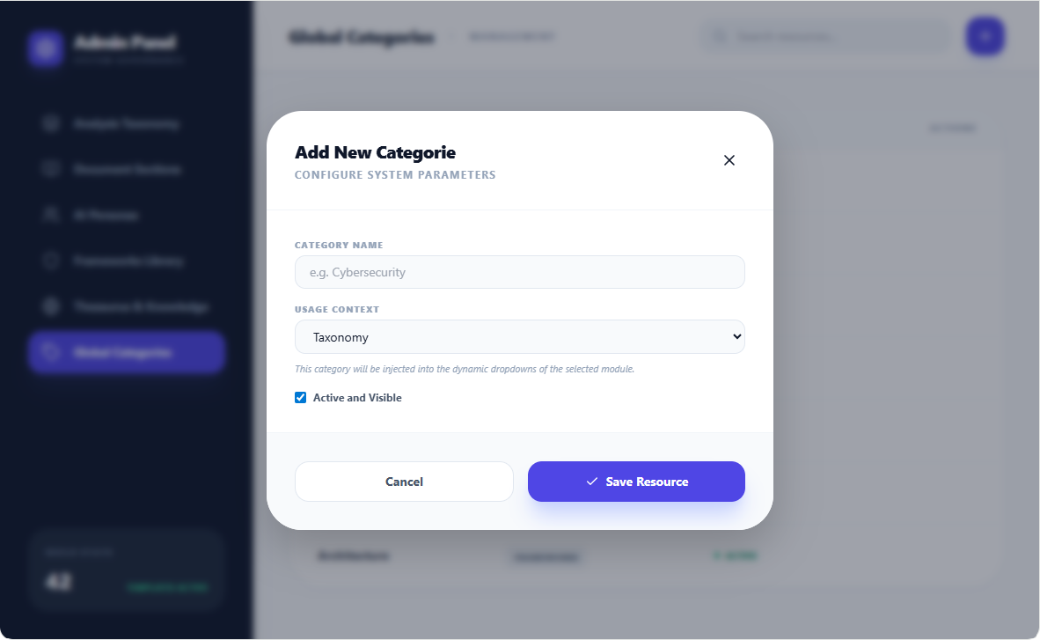
Figure 17: Categories Management - Adding a New category
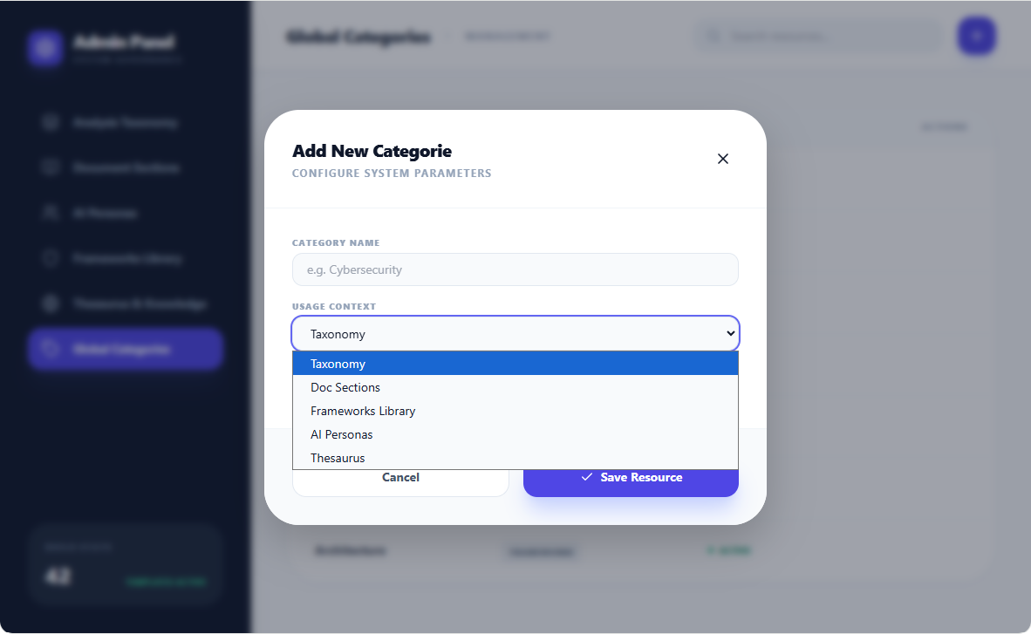
Figure 18: Categories Management - Drop Down - List if Usage Context (Match the different screens of the Admin Panel)

NOTE: Updating an entity is done using the same screens as “Adding” an entity. For example below is the screen for Updating an AI Persona
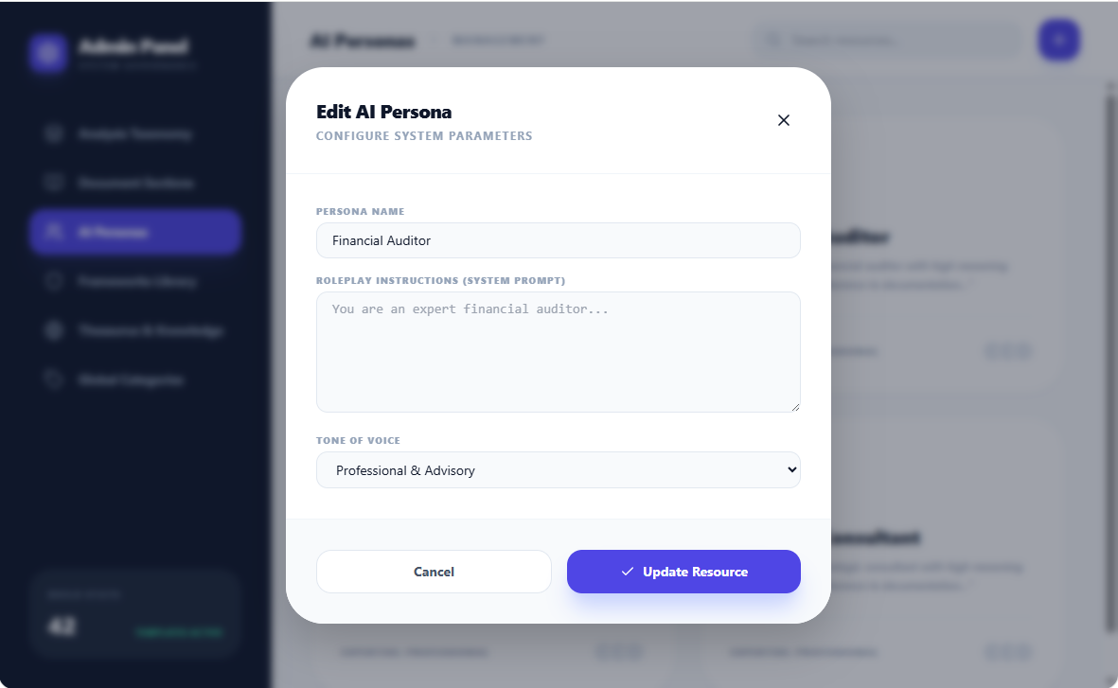
Figure 19: AI Personas - Updating an AI persona
NOTE 2 : for each entity there is an icon (pencil) for updating the category and an icon for deleting the entity (the user is requested for confirmation). These icons appear when hovering over the entity. See below an example for AI Personas:

Figure 20: AI Personas - Icons for Editing or Deleting

Code for the Mockup
Here is the code for the Mockup of the Admin Panel
import React, { useState } from 'react';
import {
Settings,
Users,
Layers,
BookOpen,
Globe,
Plus,
Edit2,
Trash2,
Search,
Shield,
Database,
Terminal,
ChevronRight,
ExternalLink,
Code,
X,
Check,
Type,
FileText,
MessageSquare,
Tag
} from 'lucide-react';

// --- Mock Data ---

const ADMIN_SECTIONS = [
{ id: 'taxonomy', name: 'Analysis Taxonomy', icon: <Layers className="w-5 h-5" />, desc: 'Categories, activity types, and input modes.' },
{ id: 'sections', name: 'Document Sections', icon: <BookOpen className="w-5 h-5" />, desc: 'Generic and domain-specific document mapping.' },
{ id: 'personas', name: 'AI Personas', icon: <Users className="w-5 h-5" />, desc: 'Roles, system prompts, and expertise tones.' },
{ id: 'frameworks', name: 'Frameworks Library', icon: <Shield className="w-5 h-5" />, desc: 'Risk, Strategy, and Architecture models.' },
{ id: 'thesaurus', name: 'Thesaurus & Knowledge', icon: <Globe className="w-5 h-5" />, desc: 'Terminology databases and industry lexicons.' },
{ id: 'categories', name: 'Global Categories', icon: <Tag className="w-5 h-5" />, desc: 'Manage dynamic lists for taxonomies, sections, and models.' },
];

const MOCK_GLOBAL_CATEGORIES = [
{ id: 'gc1', name: 'Strategic', context: 'Taxonomy', active: true },
{ id: 'gc2', name: 'Diagnostic', context: 'Taxonomy', active: true },
{ id: 'gc3', name: 'Comparison', context: 'Taxonomy', active: true },
{ id: 'gc4', name: 'Legal', context: 'Doc Sections', active: true },
{ id: 'gc5', name: 'Financial', context: 'Doc Sections', active: true },
{ id: 'gc6', name: 'Risk', context: 'Frameworks', active: true },
{ id: 'gc7', name: 'Architecture', context: 'Frameworks', active: true },
];

const MOCK_TAXONOMY = [
{ id: 't1', category: 'Comparison', type: 'Benchmarking', mode: 'Multi', desc: 'Evaluate against a reference standard.' },
{ id: 't2', category: 'Strategic', type: 'SWOT', mode: 'Single', desc: 'Analyze internal and external factors.' },
{ id: 't3', category: 'Diagnostic', type: 'Anomaly detection', mode: 'Single', desc: 'Identify irregularities in data.' },
];

const MOCK_DOC_SECTIONS = [
{ id: 's1', name: 'Executive Summary', group: 'Generic', expertise: 'Executive' },
{ id: 's2', name: 'Financial Statements', group: 'Domain-Specific', category: 'Finance' },
{ id: 's3', name: 'Liability Clauses', group: 'Domain-Specific', category: 'Legal' },
];

const MOCK_THESAURUS = [
{ id: 'th1', name: 'HL7 Medical Terminology', domain: 'Healthcare', source: 'HL7 International' },
{ id: 'th2', name: 'TOGAF Architecture Lexicon', domain: 'IT Architecture', source: 'The Open Group' },
];

const MOCK_FRAMEWORKS = [
{ id: 'swot', category: 'Strategy', name: 'SWOT Analysis', spec: 'Analyze internal Strengths/Weaknesses and external Opportunities/Threats...' },
{ id: 'stride', category: 'Risk', name: 'STRIDE Model', spec: 'Identify threats: Spoofing, Tampering, Repudiation, Information Disclosure...' },
];

const App = () => {
const [activeTab, setActiveTab] = useState('taxonomy');
const [searchQuery, setSearchQuery] = useState('');
const [showModal, setShowModal] = useState(false);
const [editingItem, setEditingItem] = useState(null);

const openAddModal = () => {
setEditingItem(null);
setShowModal(true);
};

const openEditModal = (item) => {
setEditingItem(item);
setShowModal(true);
};

const closeModal = () => setShowModal(false);

// --- Form Components for the Modal ---

const CategoryForm = () => (
<div className="space-y-4">
<div>
<label className="block text-[10px] font-black text-slate-400 uppercase mb-1 tracking-widest">Category Name</label>
<input
type="text"
className="w-full bg-slate-50 border border-slate-200 rounded-xl px-4 py-2 text-sm focus:ring-2 focus:ring-indigo-500 outline-none"
placeholder="e.g. Cybersecurity"
defaultValue={editingItem?.name || ''}
/>
</div>
<div>
<label className="block text-[10px] font-black text-slate-400 uppercase mb-1 tracking-widest">Usage Context</label>
<select
className="w-full bg-slate-50 border border-slate-200 rounded-xl px-4 py-2 text-sm focus:ring-2 focus:ring-indigo-500 outline-none"
defaultValue={editingItem?.context || 'Taxonomy'}
>
<option>Taxonomy</option>
<option>Doc Sections</option>
<option>Frameworks Library</option>
<option>AI Personas</option>
<option>Thesaurus</option>
</select>
<p className="mt-2 text-[11px] text-slate-400 leading-relaxed italic">
This category will be injected into the dynamic dropdowns of the selected module.
</p>
</div>
<div className="flex items-center gap-2">
<input type="checkbox" id="active" defaultChecked={editingItem?.active ?? true} className="rounded border-slate-300 text-indigo-600 focus:ring-indigo-500" />
<label htmlFor="active" className="text-xs font-bold text-slate-600">Active and Visible</label>
</div>
</div>
);

const TaxonomyForm = () => (
<div className="space-y-4">
<div className="grid grid-cols-2 gap-4">
<div>
<label className="block text-[10px] font-black text-slate-400 uppercase mb-1 tracking-widest">Category</label>
<select
className="w-full bg-slate-50 border border-slate-200 rounded-xl px-4 py-2 text-sm focus:ring-2 focus:ring-indigo-500 outline-none"
defaultValue={editingItem?.category || ''}
>
<option value="" disabled>Select category</option>
{MOCK_GLOBAL_CATEGORIES.filter(c => c.context === 'Taxonomy').map(c => (
<option key={c.id} value={c.name}>{c.name}</option>
))}
</select>
</div>
<div>
<label className="block text-[10px] font-black text-slate-400 uppercase mb-1 tracking-widest">Input Mode</label>
<select
className="w-full bg-slate-50 border border-slate-200 rounded-xl px-4 py-2 text-sm focus:ring-2 focus:ring-indigo-500 outline-none"
defaultValue={editingItem?.mode || 'Single'}
>
<option>Single</option>
<option>Multi</option>
</select>
</div>
</div>
<div>
<label className="block text-[10px] font-black text-slate-400 uppercase mb-1 tracking-widest">Activity Type Name</label>
<input type="text" className="w-full bg-slate-50 border border-slate-200 rounded-xl px-4 py-2 text-sm focus:ring-2 focus:ring-indigo-500 outline-none" placeholder="e.g. Gap Analysis" defaultValue={editingItem?.type || ''} />
</div>
<div>
<label className="block text-[10px] font-black text-slate-400 uppercase mb-1 tracking-widest">Description</label>
<textarea className="w-full bg-slate-50 border border-slate-200 rounded-xl px-4 py-2 text-sm focus:ring-2 focus:ring-indigo-500 outline-none h-24" placeholder="What does this activity mean?" defaultValue={editingItem?.desc || ''} />
</div>
</div>
);

const SectionForm = () => (
<div className="space-y-4">
<div>
<label className="block text-[10px] font-black text-slate-400 uppercase mb-1 tracking-widest">Section Name</label>
<input type="text" className="w-full bg-slate-50 border border-slate-200 rounded-xl px-4 py-2 text-sm focus:ring-2 focus:ring-indigo-500 outline-none" placeholder="e.g. Conclusions" defaultValue={editingItem?.name || ''} />
</div>
<div>
<label className="block text-[10px] font-black text-slate-400 uppercase mb-1 tracking-widest">Group Type</label>
<div className="grid grid-cols-2 gap-2">
<button className={`py-2 rounded-xl text-xs font-bold transition-all ${(!editingItem || editingItem.group === 'Generic') ? 'bg-indigo-600 text-white shadow-md' : 'bg-slate-100 text-slate-600'}`}>Generic</button>
<button className={`py-2 rounded-xl text-xs font-bold transition-all ${(editingItem?.group === 'Domain-Specific') ? 'bg-indigo-600 text-white shadow-md' : 'bg-slate-100 text-slate-600'}`}>Domain-Specific</button>
</div>
</div>
<div>
<label className="block text-[10px] font-black text-slate-400 uppercase mb-1 tracking-widest">Category Mapping</label>
<select
className="w-full bg-slate-50 border border-slate-200 rounded-xl px-4 py-2 text-sm focus:ring-2 focus:ring-indigo-500 outline-none"
defaultValue={editingItem?.category || 'None (Generic)'}
>
<option value="None (Generic)">None (Generic)</option>
{MOCK_GLOBAL_CATEGORIES.filter(c => c.context === 'Doc Sections').map(c => (
<option key={c.id} value={c.name}>{c.name}</option>
))}
</select>
</div>
</div>
);

const PersonaForm = () => (
<div className="space-y-4">
<div>
<label className="block text-[10px] font-black text-slate-400 uppercase mb-1 tracking-widest">Persona Name</label>
<input type="text" className="w-full bg-slate-50 border border-slate-200 rounded-xl px-4 py-2 text-sm focus:ring-2 focus:ring-indigo-500 outline-none" placeholder="e.g. Financial Auditor" defaultValue={editingItem?.role || ''} />
</div>
<div>
<label className="block text-[10px] font-black text-slate-400 uppercase mb-1 tracking-widest">Roleplay Instructions (System Prompt)</label>
<textarea className="w-full bg-slate-50 border border-slate-200 rounded-xl px-4 py-2 text-sm font-mono focus:ring-2 focus:ring-indigo-500 outline-none h-32" placeholder="You are an expert financial auditor..." defaultValue={editingItem?.systemPrompt || ''} />
</div>
<div>
<label className="block text-[10px] font-black text-slate-400 uppercase mb-1 tracking-widest">Tone of Voice</label>
<select
className="w-full bg-slate-50 border border-slate-200 rounded-xl px-4 py-2 text-sm focus:ring-2 focus:ring-indigo-500 outline-none"
defaultValue={editingItem?.tone || 'Professional & Advisory'}
>
<option>Fact-based & Dry</option>
<option>Professional & Advisory</option>
<option>Executive & Concise</option>
<option>Technical & Exhaustive</option>
</select>
</div>
</div>
);

const FrameworkForm = () => (
<div className="space-y-4">
<div className="grid grid-cols-2 gap-4">
<div>
<label className="block text-[10px] font-black text-slate-400 uppercase mb-1 tracking-widest">Category</label>
<select
className="w-full bg-slate-50 border border-slate-200 rounded-xl px-4 py-2 text-sm focus:ring-2 focus:ring-indigo-500 outline-none"
defaultValue={editingItem?.category || ''}
>
<option value="" disabled>Select category</option>
{MOCK_GLOBAL_CATEGORIES.filter(c => c.context === 'Frameworks').map(c => (
<option key={c.id} value={c.name}>{c.name}</option>
))}
</select>
</div>
<div>
<label className="block text-[10px] font-black text-slate-400 uppercase mb-1 tracking-widest">Name</label>
<input type="text" className="w-full bg-slate-50 border border-slate-200 rounded-xl px-4 py-2 text-sm focus:ring-2 focus:ring-indigo-500 outline-none" placeholder="e.g. SWOT" defaultValue={editingItem?.name || ''} />
</div>
</div>
<div>
<label className="block text-[10px] font-black text-slate-400 uppercase mb-1 tracking-widest">AI Specification (Analysis Rules)</label>
<textarea className="w-full bg-slate-50 border border-slate-200 rounded-xl px-4 py-2 text-sm font-mono focus:ring-2 focus:ring-indigo-500 outline-none h-48" placeholder="Define exactly how the AI should apply this framework..." defaultValue={editingItem?.spec || ''} />
</div>
<div>
<label className="block text-[10px] font-black text-slate-400 uppercase mb-1 tracking-widest">External Documentation URL</label>
<div className="flex gap-2">
<input type="text" className="flex-1 bg-slate-50 border border-slate-200 rounded-xl px-4 py-2 text-sm focus:ring-2 focus:ring-indigo-500 outline-none" placeholder="https://..." />
<button className="p-2 bg-slate-100 rounded-xl text-slate-500"><ExternalLink size={18} /></button>
</div>
</div>
</div>
);

const ThesaurusForm = () => (
<div className="space-y-4">
<div>
<label className="block text-[10px] font-black text-slate-400 uppercase mb-1 tracking-widest">Thesaurus Name</label>
<input type="text" className="w-full bg-slate-50 border border-slate-200 rounded-xl px-4 py-2 text-sm focus:ring-2 focus:ring-indigo-500 outline-none" placeholder="e.g. HL7 Standards" defaultValue={editingItem?.name || ''} />
</div>
<div className="grid grid-cols-2 gap-4">
<div>
<label className="block text-[10px] font-black text-slate-400 uppercase mb-1 tracking-widest">Industry / Domain</label>
<input type="text" className="w-full bg-slate-50 border border-slate-200 rounded-xl px-4 py-2 text-sm focus:ring-2 focus:ring-indigo-500 outline-none" placeholder="e.g. Healthcare" defaultValue={editingItem?.domain || ''} />
</div>
<div>
<label className="block text-[10px] font-black text-slate-400 uppercase mb-1 tracking-widest">Source Organization</label>
<input type="text" className="w-full bg-slate-50 border border-slate-200 rounded-xl px-4 py-2 text-sm focus:ring-2 focus:ring-indigo-500 outline-none" placeholder="e.g. ISO" defaultValue={editingItem?.source || ''} />
</div>
</div>
<div>
<label className="block text-[10px] font-black text-slate-400 uppercase mb-1 tracking-widest">Terminology Database (JSON Mapping)</label>
<textarea className="w-full bg-slate-50 border border-slate-200 rounded-xl px-4 py-2 text-sm font-mono focus:ring-2 focus:ring-indigo-500 outline-none h-32" placeholder="{ 'term': 'definition', ... }" />
</div>
</div>
);

return (
<div className="flex h-screen bg-slate-50 font-sans text-slate-900 overflow-hidden relative">

{/* --- Modal Overlay --- */}
{showModal && (
<div className="fixed inset-0 z-[100] flex items-center justify-center p-6 animate-in fade-in duration-200">
<div className="absolute inset-0 bg-slate-900/40 backdrop-blur-sm" onClick={closeModal} />
<div className="relative bg-white w-full max-w-xl rounded-[2.5rem] shadow-[0_20px_50px_rgba(0,0,0,0.2)] overflow-hidden flex flex-col animate-in zoom-in-95 duration-200">
<header className="p-8 border-b border-slate-100 flex items-center justify-between">
<div>
<h3 className="text-xl font-black tracking-tight">{editingItem ? 'Edit' : 'Add New'} {ADMIN_SECTIONS.find(s => s.id === activeTab)?.name.replace('Global ', '').slice(0, -1)}</h3>
<p className="text-xs font-bold text-slate-400 uppercase tracking-widest mt-1">Configure system parameters</p>
</div>
<button onClick={closeModal} className="p-2 hover:bg-slate-100 rounded-xl transition-colors">
<X className="w-5 h-5" />
</button>
</header>

<div className="p-8 overflow-y-auto max-h-[70vh]">
{activeTab === 'categories' && <CategoryForm />}
{activeTab === 'taxonomy' && <TaxonomyForm />}
{activeTab === 'sections' && <SectionForm />}
{activeTab === 'personas' && <PersonaForm />}
{activeTab === 'frameworks' && <FrameworkForm />}
{activeTab === 'thesaurus' && <ThesaurusForm />}
</div>

<footer className="p-8 bg-slate-50 border-t border-slate-100 flex gap-4">
<button onClick={closeModal} className="flex-1 py-3 px-6 bg-white border border-slate-200 rounded-2xl font-bold text-sm text-slate-600 hover:bg-slate-100 transition-all">Cancel</button>
<button className="flex-1 py-3 px-6 bg-indigo-600 text-white rounded-2xl font-bold text-sm shadow-xl shadow-indigo-200 hover:bg-indigo-500 transition-all flex items-center justify-center gap-2">
<Check className="w-4 h-4" /> {editingItem ? 'Update' : 'Save'} Resource
</button>
</footer>
</div>
</div>
)}

{/* --- Sidebar Navigation --- */}
<aside className="w-72 bg-slate-900 flex flex-col shadow-xl z-20">
<div className="p-8">
<div className="flex items-center gap-3 mb-10">
<div className="w-10 h-10 bg-indigo-600 rounded-xl flex items-center justify-center text-white shadow-lg shadow-indigo-500/20">
<Settings className="w-6 h-6" />
</div>
<div>
<h1 className="font-black text-xl text-white tracking-tighter">Admin Panel</h1>
<p className="text-[10px] font-bold text-slate-500 uppercase tracking-widest">System Governance</p>
</div>
</div>

<nav className="space-y-1">
{ADMIN_SECTIONS.map((section) => (
<button
key={section.id}
onClick={() => setActiveTab(section.id)}
className={`w-full flex items-center gap-4 px-4 py-3.5 rounded-2xl transition-all ${
activeTab === section.id
? 'bg-indigo-600 text-white shadow-xl shadow-indigo-500/10'
: 'text-slate-400 hover:text-white hover:bg-slate-800'
}`}
>
{section.icon}
<span className="font-bold text-sm tracking-tight">{section.name}</span>
</button>
))}
</nav>
</div>

<div className="mt-auto p-8">
<div className="p-5 bg-slate-800 rounded-3xl">
<p className="text-[10px] font-black text-slate-500 uppercase tracking-widest mb-2">Build Stats</p>
<div className="flex items-end justify-between text-white">
<span className="text-2xl font-black">42</span>
<span className="text-[10px] font-bold text-emerald-400 uppercase">Templates Active</span>
</div>
</div>
</div>
</aside>

{/* --- Main Content Area --- */}
<main className="flex-1 flex flex-col overflow-hidden">
<header className="h-20 bg-white border-b border-slate-200 px-10 flex items-center justify-between shadow-sm z-10">
<div className="flex items-center gap-3">
<h2 className="text-xl font-black tracking-tight text-slate-800">
{ADMIN_SECTIONS.find(s => s.id === activeTab)?.name}
</h2>
<ChevronRight className="w-4 h-4 text-slate-300" />
<span className="text-xs font-bold text-slate-400 uppercase tracking-widest">Management</span>
</div>

<div className="flex items-center gap-4">
<div className="relative">
<Search className="w-4 h-4 absolute left-4 top-1/2 -translate-y-1/2 text-slate-400" />
<input
type="text"
placeholder="Search resources..."
className="pl-11 pr-4 py-2.5 bg-slate-100 border-none rounded-2xl text-sm w-72 focus:ring-2 focus:ring-indigo-500 transition-all outline-none"
value={searchQuery}
onChange={(e) => setSearchQuery(e.target.value)}
/>
</div>
<button
onClick={openAddModal}
className="bg-indigo-600 text-white p-3 rounded-2xl hover:bg-indigo-500 transition-all shadow-lg shadow-indigo-100 flex items-center gap-2"
>
<Plus className="w-5 h-5" />
</button>
</div>
</header>

<div className="flex-1 overflow-y-auto p-10 bg-slate-50/50">
<div className="max-w-6xl mx-auto space-y-6">

{/* --- Analysis Taxonomy View --- */}
{activeTab === 'taxonomy' && (
<div className="bg-white rounded-[2.5rem] border border-slate-100 shadow-sm overflow-hidden">
<table className="w-full text-left border-collapse">
<thead>
<tr className="bg-slate-50/80">
<th className="px-8 py-4 text-[10px] font-black text-slate-400 uppercase tracking-widest border-b border-slate-100">Category</th>
<th className="px-8 py-4 text-[10px] font-black text-slate-400 uppercase tracking-widest border-b border-slate-100">Activity Type</th>
<th className="px-8 py-4 text-[10px] font-black text-slate-400 uppercase tracking-widest border-b border-slate-100">Input Mode</th>
<th className="px-8 py-4 text-[10px] font-black text-slate-400 uppercase tracking-widest border-b border-slate-100 text-right">Actions</th>
</tr>
</thead>
<tbody>
{MOCK_TAXONOMY.map((item) => (
<tr key={item.id} className="hover:bg-slate-50 transition-colors group">
<td className="px-8 py-5 border-b border-slate-50">
<span className="text-xs font-bold text-indigo-600 bg-indigo-50 px-2 py-1 rounded-md">{item.category}</span>
</td>
<td className="px-8 py-5 border-b border-slate-50 text-sm font-bold text-slate-700">{item.type}</td>
<td className="px-8 py-5 border-b border-slate-50 text-xs text-slate-500 font-medium">{item.mode}</td>
<td className="px-8 py-5 border-b border-slate-50 text-right">
<div className="flex justify-end gap-2 opacity-0 group-hover:opacity-100 transition-opacity">
<button onClick={() => openEditModal(item)} className="p-2 bg-slate-100 rounded-xl text-slate-500 hover:text-indigo-600"><Edit2 size={14} /></button>
<button className="p-2 bg-slate-100 rounded-xl text-slate-500 hover:text-rose-600"><Trash2 size={14} /></button>
</div>
</td>
</tr>
))}
</tbody>
</table>
</div>
)}

{/* --- Document Sections View --- */}
{activeTab === 'sections' && (
<div className="grid grid-cols-1 md:grid-cols-2 lg:grid-cols-3 gap-6">
{MOCK_DOC_SECTIONS.map((section) => (
<div key={section.id} className="bg-white p-6 rounded-[2rem] border border-slate-100 shadow-sm flex items-center justify-between group">
<div className="flex items-center gap-4">
<div className="p-3 bg-indigo-50 rounded-2xl text-indigo-600"><Type size={20} /></div>
<div>
<h4 className="font-bold text-slate-800 tracking-tight">{section.name}</h4>
<p className="text-[10px] font-black text-slate-400 uppercase tracking-widest mt-0.5">{section.group} • {section.expertise || section.category}</p>
</div>
</div>
<button onClick={() => openEditModal(section)} className="opacity-0 group-hover:opacity-100 p-2 text-slate-300 hover:text-indigo-600 transition-all">
<Edit2 size={16} />
</button>
</div>
))}
<div onClick={openAddModal} className="border-2 border-dashed border-slate-200 rounded-[2rem] p-6 flex items-center justify-center gap-3 text-slate-400 hover:border-indigo-300 hover:text-indigo-600 transition-all cursor-pointer group">
<Plus size={20} />
<span className="font-bold text-sm tracking-tight">Add Section</span>
</div>
</div>
)}

{/* --- Thesaurus View --- */}
{activeTab === 'thesaurus' && (
<div className="grid grid-cols-1 md:grid-cols-2 gap-6">
{MOCK_THESAURUS.map((th) => (
<div key={th.id} className="bg-white p-8 rounded-[2.5rem] border border-slate-100 shadow-sm flex flex-col gap-6 relative overflow-hidden group">
<div className="absolute top-0 right-0 p-4 opacity-0 group-hover:opacity-100 transition-opacity">
<button onClick={() => openEditModal(th)} className="p-2 bg-slate-100 rounded-xl text-slate-500"><Edit2 size={16} /></button>
</div>
<div className="flex items-center gap-4">
<div className="w-14 h-14 bg-indigo-600 rounded-2xl flex items-center justify-center text-white shadow-lg shadow-indigo-200">
<Globe size={24} />
</div>
<div>
<h4 className="text-xl font-black tracking-tight">{th.name}</h4>
<span className="text-[10px] font-black text-indigo-600 bg-indigo-50 px-2 py-0.5 rounded-md uppercase tracking-widest">{th.domain}</span>
</div>
</div>
<div className="p-4 bg-slate-50 rounded-2xl flex items-center justify-between border border-slate-100">
<div className="flex items-center gap-2">
<Database size={14} className="text-slate-400" />
<span className="text-xs font-bold text-slate-500">Source: {th.source}</span>
</div>
<span className="text-[10px] font-black text-slate-400 uppercase tracking-widest">Active Database</span>
</div>
</div>
))}
</div>
)}

{/* --- AI Personas View --- */}
{activeTab === 'personas' && (
<div className="grid grid-cols-1 md:grid-cols-2 gap-6">
{['Legal Counsel', 'Financial Auditor', 'Cyber Security Architect', 'Strategic Consultant'].map(role => (
<div key={role} className="bg-white p-8 rounded-[2.5rem] border border-slate-100 shadow-sm group">
<div className="flex justify-between items-start mb-6">
<div className="w-14 h-14 bg-slate-50 rounded-2xl flex items-center justify-center text-slate-500 border border-slate-100"><Users size={24} /></div>
<div className="flex gap-1 opacity-0 group-hover:opacity-100 transition-opacity">
<button onClick={() => openEditModal({role})} className="p-2 bg-slate-50 rounded-xl text-slate-400 hover:text-indigo-600"><Edit2 size={16} /></button>
<button className="p-2 bg-slate-50 rounded-xl text-slate-400 hover:text-rose-600"><Trash2 size={16} /></button>
</div>
</div>
<h4 className="text-xl font-black mb-2 text-slate-800">{role}</h4>
<p className="text-xs text-slate-400 font-medium leading-relaxed italic mb-6">"Acts as a senior {role.toLowerCase()} with high reasoning depth and strict adherence to documentation..."</p>
<div className="pt-6 border-t border-slate-50 flex items-center justify-between">
<span className="text-[10px] font-black text-slate-400 uppercase tracking-widest">Expertise: Professional</span>
<div className="flex -space-x-2">
{[1,2,3].map(i => <div key={i} className="w-6 h-6 rounded-full border-2 border-white bg-slate-200" />)}
</div>
</div>
</div>
))}
</div>
)}

{/* --- Frameworks View --- */}
{activeTab === 'frameworks' && (
<div className="space-y-4">
{MOCK_FRAMEWORKS.map(fw => (
<div key={fw.id} className="bg-white p-6 rounded-[2rem] border border-slate-100 shadow-sm group flex flex-col md:flex-row gap-6">
<div className="w-16 h-16 bg-slate-50 rounded-2xl border flex items-center justify-center text-slate-300 shrink-0"><Shield size={28} /></div>
<div className="flex-1">
<div className="flex items-center gap-3 mb-2">
<h4 className="text-lg font-black tracking-tight">{fw.name}</h4>
<span className="text-[10px] font-black text-indigo-600 bg-indigo-50 px-2 py-0.5 rounded-md uppercase tracking-widest">{fw.category}</span>
</div>
<div className="bg-slate-900/95 p-4 rounded-2xl flex items-start gap-3 border border-slate-800">
<Code size={16} className="text-indigo-400 mt-1 shrink-0" />
<p className="text-[11px] font-mono text-slate-400 leading-relaxed line-clamp-2">{fw.spec}</p>
</div>
</div>
<div className="flex md:flex-col gap-2 justify-center pl-6 border-l border-slate-50 border-dashed">
<button onClick={() => openEditModal(fw)} className="p-3 bg-slate-50 text-slate-400 rounded-xl hover:text-indigo-600 hover:bg-indigo-50 transition-all"><Edit2 size={18} /></button>
<button className="p-3 bg-slate-50 text-slate-400 rounded-xl hover:text-rose-600 hover:bg-rose-50 transition-all"><Trash2 size={18} /></button>
</div>
</div>
))}
</div>
)}

{/* --- Global Categories View --- */}
{activeTab === 'categories' && (
<div className="bg-white rounded-[2.5rem] border border-slate-100 shadow-sm overflow-hidden">
<table className="w-full text-left border-collapse">
<thead>
<tr className="bg-slate-50/80">
<th className="px-8 py-4 text-[10px] font-black text-slate-400 uppercase tracking-widest border-b border-slate-100">Name</th>
<th className="px-8 py-4 text-[10px] font-black text-slate-400 uppercase tracking-widest border-b border-slate-100">Usage Context</th>
<th className="px-8 py-4 text-[10px] font-black text-slate-400 uppercase tracking-widest border-b border-slate-100">Status</th>
<th className="px-8 py-4 text-[10px] font-black text-slate-400 uppercase tracking-widest border-b border-slate-100 text-right">Actions</th>
</tr>
</thead>
<tbody>
{MOCK_GLOBAL_CATEGORIES.map((item) => (
<tr key={item.id} className="hover:bg-slate-50 transition-colors group">
<td className="px-8 py-5 border-b border-slate-50 text-sm font-bold text-slate-700">{item.name}</td>
<td className="px-8 py-5 border-b border-slate-50">
<span className="text-[10px] font-black text-slate-500 border border-slate-200 px-2 py-1 rounded-md bg-slate-100 uppercase">{item.context}</span>
</td>
<td className="px-8 py-5 border-b border-slate-50">
{item.active ? (
<span className="flex items-center gap-1.5 text-emerald-600 text-[10px] font-black uppercase">
<div className="w-1.5 h-1.5 bg-emerald-500 rounded-full" /> Active
</span>
) : (
<span className="flex items-center gap-1.5 text-slate-400 text-[10px] font-black uppercase">
<div className="w-1.5 h-1.5 bg-slate-300 rounded-full" /> Inactive
</span>
)}
</td>
<td className="px-8 py-5 border-b border-slate-50 text-right">
<div className="flex justify-end gap-2 opacity-0 group-hover:opacity-100 transition-opacity">
<button onClick={() => openEditModal(item)} className="p-2 bg-slate-100 rounded-xl text-slate-500 hover:text-indigo-600"><Edit2 size={14} /></button>
<button className="p-2 bg-slate-100 rounded-xl text-slate-500 hover:text-rose-600"><Trash2 size={14} /></button>
</div>
</td>
</tr>
))}
</tbody>
</table>
</div>
)}

</div>
</div>
</main>
</div>
);
};

export default App;

